# Simplistic Approach

## UML Class Diagrams

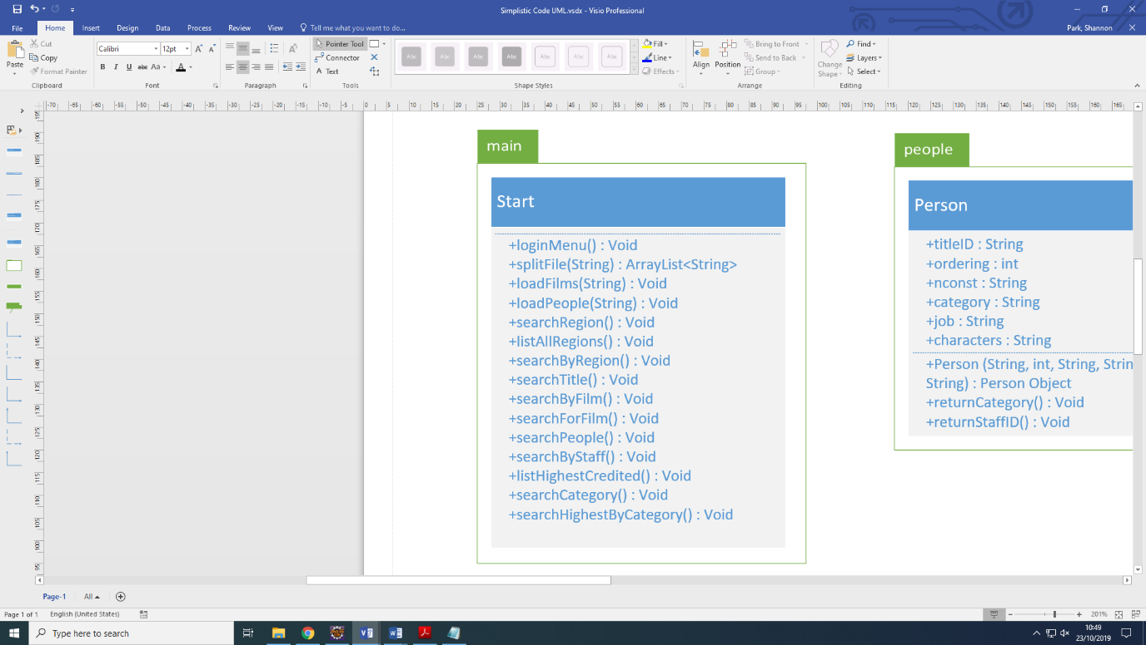

Once the program is executed the main method calls both of the file load methods and calls the initial menu. This menu provides functionality options to a user and calls on the appropriate method for their choice. During file load, it calls on the deserialise file method, which splits the current line by commas and saves the substrings to an array list. This array list is used to create the relevant object for the file data.

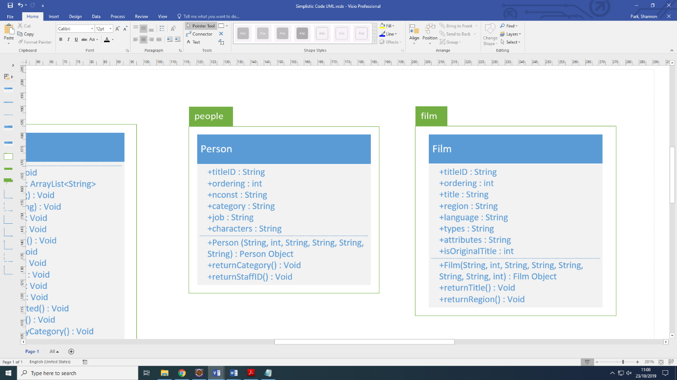

The person object

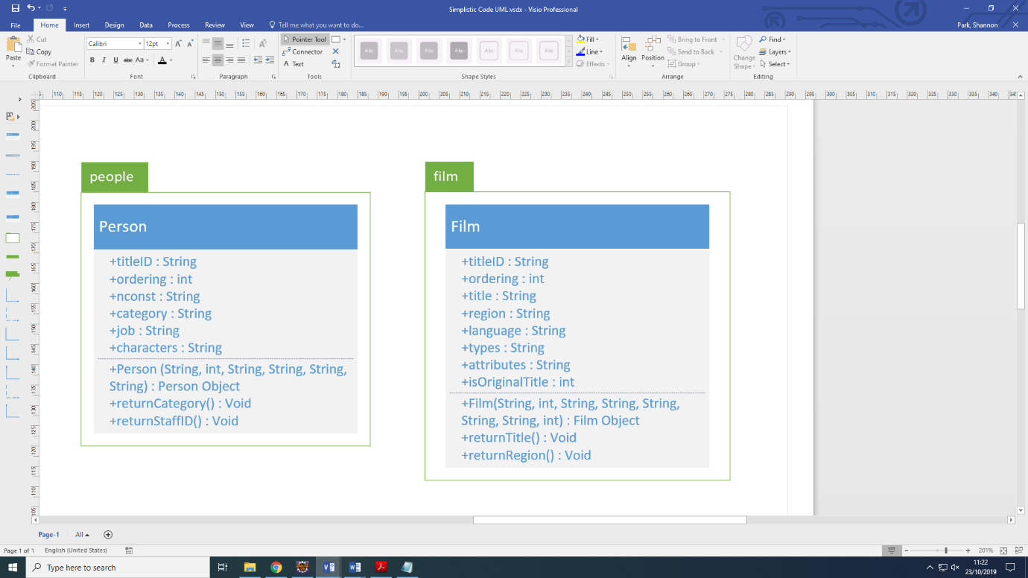

## Solutions

### Search

### Sort

### Functions